

SIMATS ENGINEERING

Saveetha Institute of Medical and Technical Sciences
Chennai- 602105

Student Name: R. Jayanth Reg. No:192424286
Course Code: DSA0216 Slot: B
Course Name: Computer Vision with OpenCV for Modern AI
Course Faculty: Dr. Senthilvadivu S, Dr. Kumaragurubaran T
Project Title: Automatic Fruit ripeness Detection and Quality Grading Using Image Analysis

Module Photographs:
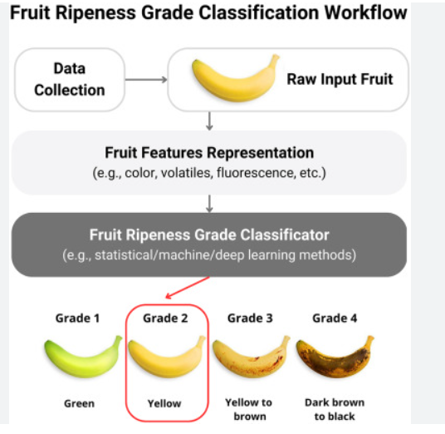
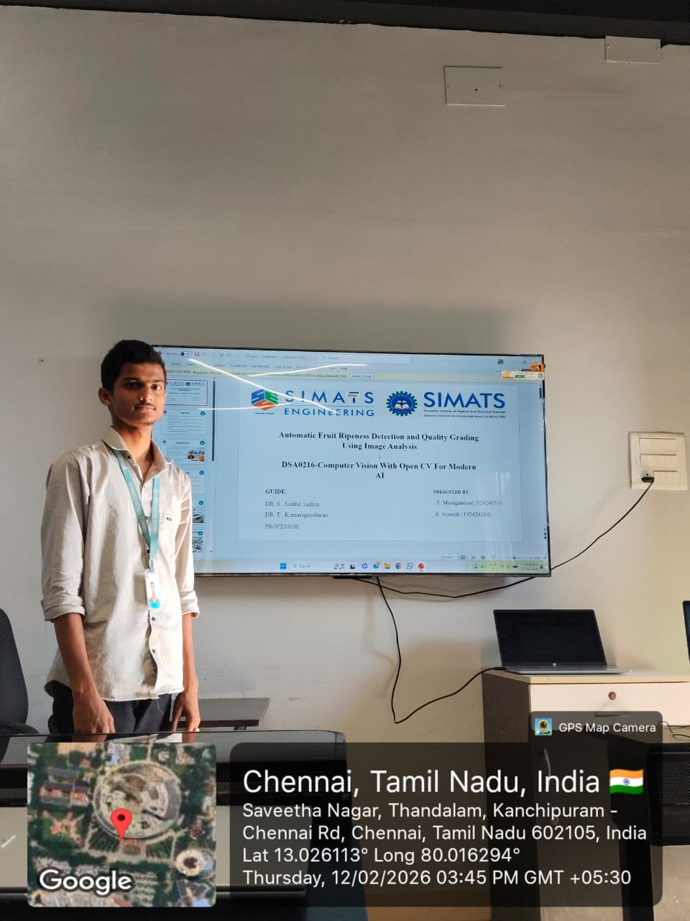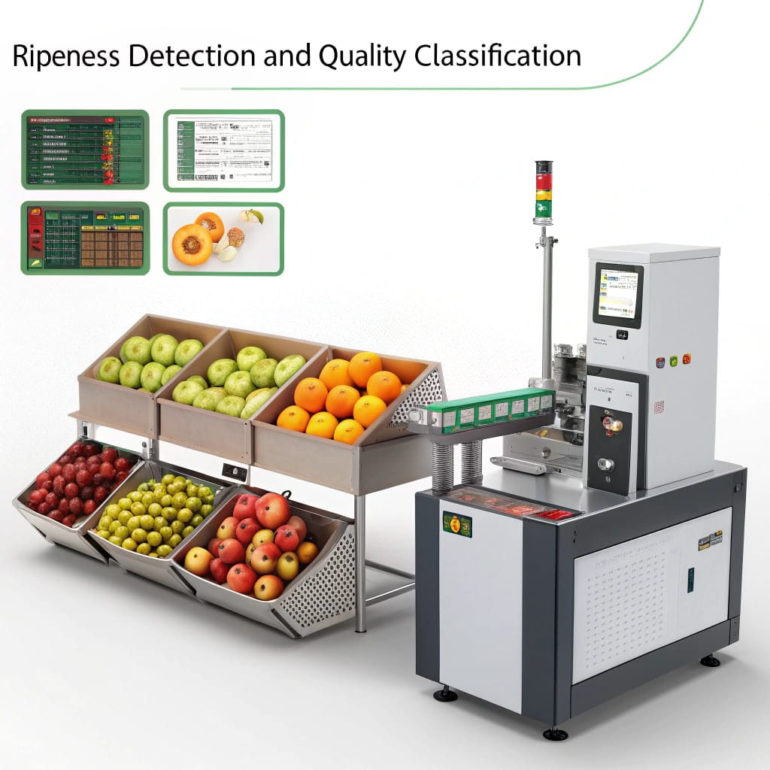
Project Description: (here you write what you did in this project (contribution) including Model Description
- Fruit images are captured using a camera under proper lighting conditions for analysis.
- The image is pre-processed by resizing, noise removal, and converting to HSV colour space.
- Colour, texture, and size features are extracted to determine ripeness level.
- Machine learning algorithms classify the fruit as unripe, ripe, or overripe.
- The fruit is graded into quality categories based on defects and uniformity.

Student Signature Guide Signature

